DNA Function, Structure and Replication

DNA Function, part 1
1. Everyone has heard of DNA, but what is it and what does it do? Briefly summarize what you already know about DNA.

A key fact about DNA is that each DNA molecule contains many genes. A gene is a segment of DNA that provides the instructions needed to make a protein.

A cell needs many different types of proteins in order to function. For example, a cell needs:
- protein enzymes to carry out the chemical reactions that sustain life;
- transport proteins to move ions and molecules into and out of the cell.

2. All organisms, including humans, other animals, plants, and bacteria, have DNA inside their cells. Why does each type of cell need to have DNA?

Genes influence an organism's characteristics by determining which proteins the organism makes. The chart below shows the effects of two different versions of a human gene.

Gene in DNA | → | Protein | → | Characteristic
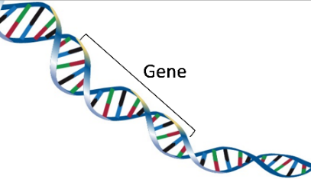 | → | 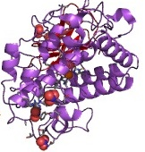 | → | 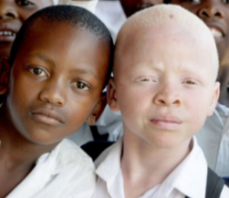
One version of the gene gives the instructions for making a functional protein enzyme. | → | The functional enzyme makes melanin, the pigment molecule in skin and hair. | → | Normal skin and hair color
Another version of this gene gives the instructions for making a non-functional version of this protein. | → | The non-functional protein does not make melanin. | → | Very pale skin and hair = albinism

3. Explain how a difference in their DNA can result in one boy being albino and the other boy having normal skin and hair color. (Hint: A complete answer will include the words: gene, protein, enzyme, and melanin.)

DNA Structure

Understanding the structure of DNA will help you to understand how DNA gives the instructions for making proteins. A DNA molecule has two strands of nucleotides twisted together in a long spiral called a double helix. This figure shows a small part of a long double helix and the chemical structure of a short segment of this double helix.

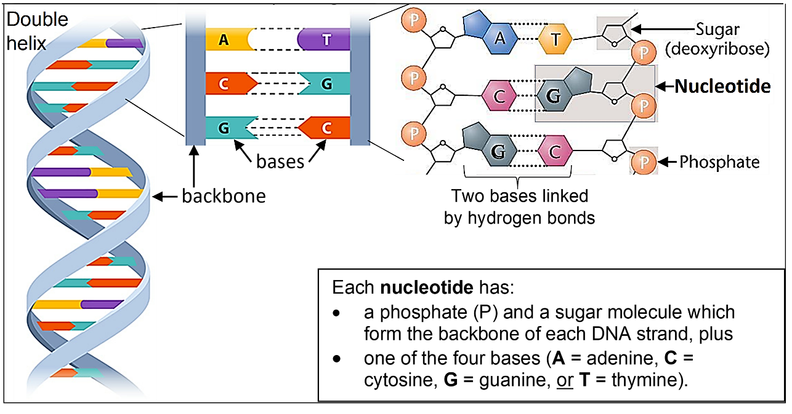

4. For the DNA strand on the far right, draw a rectangle around the top nucleotide. Circle the base in that nucleotide.

5a. What are the four different types of bases? ___ ___ ___ ___

5b. Each base in one strand of the DNA double helix is paired with a base in the other strand. The base-pairing rules describe which bases pair together in a DNA double helix.
A in one strand pairs with ____ in the other strand.
C in one strand pairs with ____ in the other strand.

Chemistry determines which bases pair with each other. You can remember the base-pairing rules as “Apples grow in Trees“ and “The Car goes in the Garage”.

6. The only difference between the various DNA nucleotides is the base each nucleotide contains. Therefore, a nucleotide is given the same symbol as the base it contains (A, C, G, or T) and the base-pairing rules apply to the nucleotides. The nucleotides that pair together are called complementary nucleotides. Which nucleotide is complementary to G?

7. The sugar of each nucleotide is bound to the phosphate of the next nucleotide to make a backbone of each DNA strand. Use a dashed line to draw a rectangle around the backbone of a DNA strand on the right in the figure above.

8. In the double helix diagram, the backbone of each strand is shown as a helical ribbon. What is represented by each horizontal bar in the double helix diagram?

A typical DNA molecule contains millions of nucleotides, so DNA is a very long thin molecule. Proteins help to organize this long thin molecule in the small space of the nucleus. The combination of a DNA molecule and the associated proteins is called a chromosome. Each human chromosome has hundreds or thousands of genes.  9. Explain why none of the diagrams of the double helix show a whole DNA molecule. | 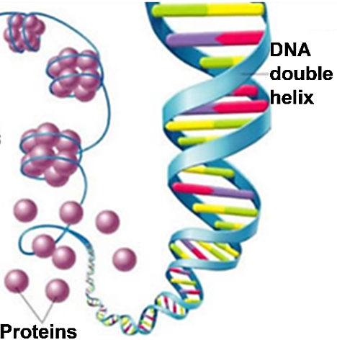

DNA Function, part 2
Different versions of a gene have a different sequence of nucleotides. The figure below shows that:
the sequence of nucleotides in the DNA of a gene
determines the sequence of nucleotides in RNA which
determines the sequence of amino acids in a protein which
determines the structure and function of the protein which
influences the characteristics of the organism.

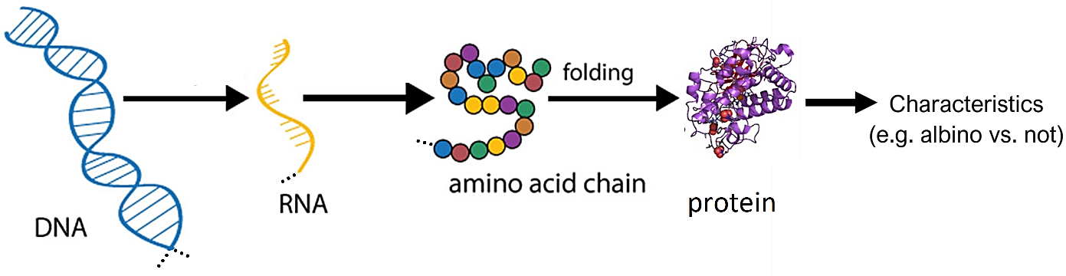

10. To review this information and learn more, watch the video, “What is DNA and how does it work?” (https://www.statedclearly.com/videos/what-is-dna/). What did you learn about the functions of RNA and ribosomes from this video?

11. Explain how a difference in the sequence of nucleotides in a gene can result in one boy being albino and another boy having normal skin and hair color. (Hints: See the bottom half of page 1. A complete answer will include these terms: sequence, nucleotides, amino acids, protein, enzyme, and melanin.)

DNA Replication

Our bodies need to make new cells to grow and to replace damaged cells. This figure shows how new cells are formed by cell division. Before a cell divides into two daughter cells, the cell makes a copy of all of its DNA (DNA replication).

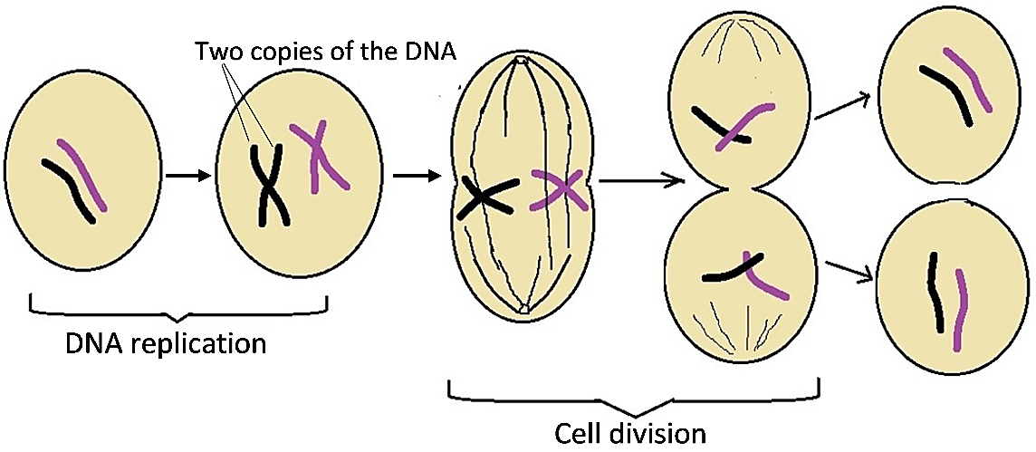

12. Explain why a cell needs to replicate its DNA before the cell divides into two daughter cells. (Hint: See top half of page 1.)

This figure shows how DNA replication produces two new DNA molecules that are identical to the original DNA molecule.  - First, the two strands of the DNA double helix are separated.  - Then, the base-pairing rules are used to add complementary nucleotides to form the second strand in each new DNA double helix molecule.  13a. This figure shows two of the free nucleotides (A and G). Which nucleotide will be added next to the top of the growing new DNA strand on the left? ___  13b. How do you know?  13c. Look at the two double helices at the bottom of the figure. Do they have identical nucleotide sequences? Describe any differences. | 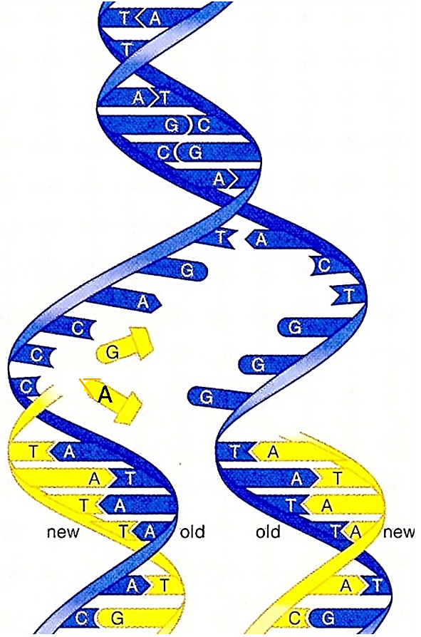

14a. During DNA replication, the double helix structure and the base-pairing rules work together to make two DNA molecules that are identical to the original DNA molecule. How does the double helix structure help to produce two new DNA molecules that are identical to the original DNA molecule?

14b. How do the base-pairing rules help to produce two new DNA molecules that are identical to the original DNA molecule?

14c. Why is it important for both copies of the DNA produced by DNA replication to have the exact same sequence of nucleotides as the original DNA?

To review this material and learn more, watch the first 6 minutes of “DNA Structure and Replication” (https://www.youtube.com/watch?v=4YNDB_zSzfE). Stop when the narrator says, “For a closer look at how this works, let’s head over to the Thought Bubble”.

15. Summarize 5 major points from this video, including new things you learned and old things that were reinforced.

By Dr. Ingrid Waldron, Biology Department, University of Pennsylvania, © 2026. This Student Handout and Teacher Notes (with instructional suggestions and background biology) are available at https://serendipstudio.org/exchange/bioactivities/DNA

